Inhalt
Trace width calculation 2
Power sauna oven with 6KW 2
Results for 6KW 2
Power sauna oven width 9KW 3
Results for 9KW 3

Trace width calculation

Introduction
From the web:
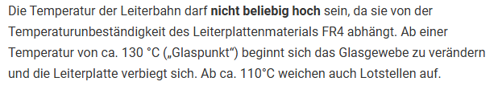
- Tmax chosen = 80°C

Power sauna oven with 6KW
Current per line: 6KW complete, 2KW per line
Iline (L1, L2, L3) = P / U = 2000/230 = 8,7A
Chosen for calculation 9A
Trace width: 3,0mm
Caclulator on: https://www.leiton.de/leiton-tools-leiterbahnerwaermung.html
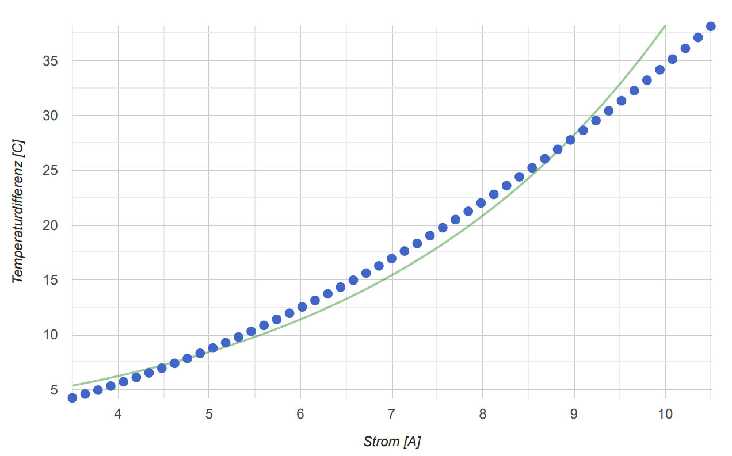

Results for 6KW
Delta T expected: + 28°C
Final trace temperature: 22°C room + 28°C heating = 50°C => OK

Power sauna oven width 9KW
Current per line: 9KW complete, 3KW per line
Iline (L1, L2, L3) = P / U = 3000/230 = 13,04A
Chosen for calculation 13A
Trace width: 3,5mm
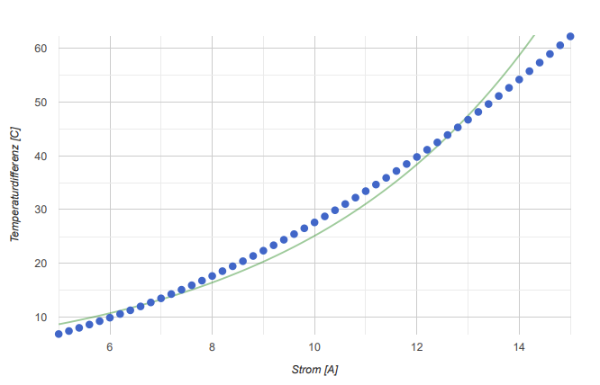

Results for 9KW
Delta T expected: + 47°C
Final trace temperature: 22°C room + 28°C heating = 69°C => OK
Although I have an 6KW oven, the design should be also OK for 9KW.
If possible 3.5 mm traces should be used.

Addendum

Table for temperature rise depending on current and trace width
